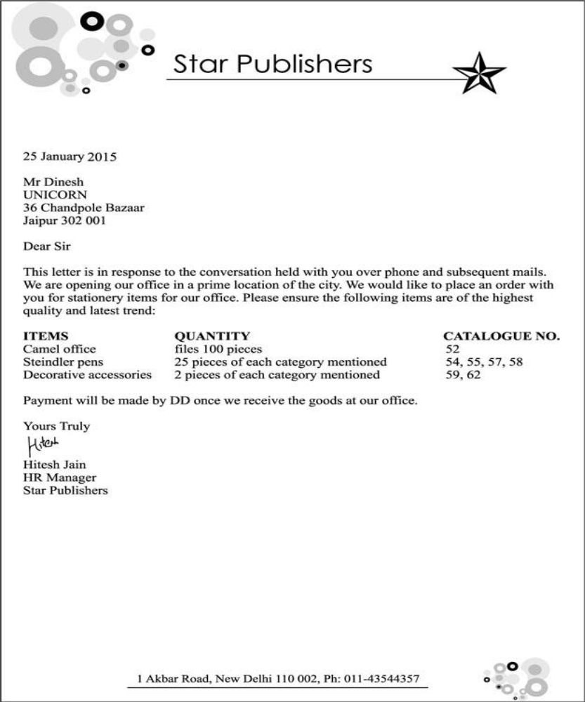
Letter of order placement
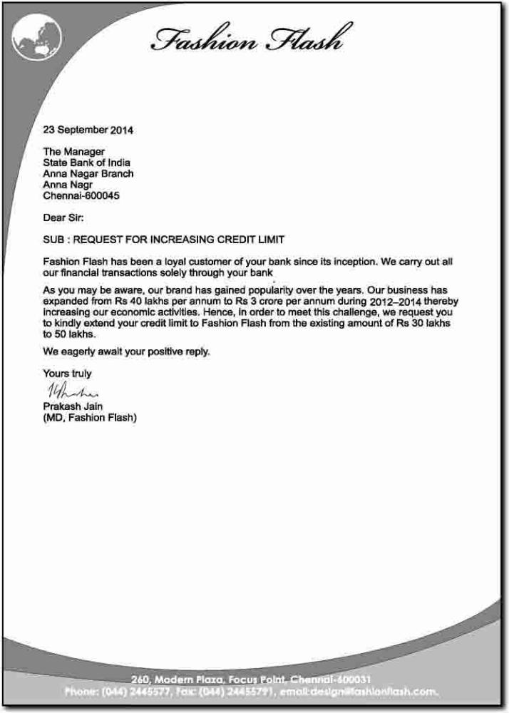

Letter of request

Letter of Instruction

25/05/2022

Dear Prof. S. Sharma,

All staff members are requested to take care of the following points during comprehensive examination with full alertness.
A. Question Paper Production :-
A1. The question papers must be word-processed.
A2. Be present in the reprography while copies of the question paper are being made.
A3. Collect Original question paper, rota master, etc.
A4. Erase the word processed file of the question paper from the hard disc and keep the soft copy with you in secondary storage form.
A5. Confirm that the Rubber Blanket in the Rota machine is cleaned after the work is over and also collect the Master Copy of the question paper as well as the copies of question paper not properly produced (if any).
A6. Do not bring question papers outside the reprography room without keeping them inside envelopes.
A7. Question paper & other material related to it must be kept under lock & key.
B. Invigilation:
Make the following announcements for students necessarily before the start of the exam :
1 Do not carry your mobile phones along with you. If you have one with you, please keep the same in switched-off mode on the invigilator’s table.
2 In case of a closed book test, deposit any unwanted slip / paper or any other materials, which may be of direct / indirect help in the exam.
3 Please keep your id cards on your desk during the exam.
4 Do not involve yourself in any kind of direct / indirect copying or cheating attempt.
B1. Check the identity of the student by his/ her identity card/ library card.
B2. Take attendance on the prescribed form and tally the total by counting the students present. Draw a rough sketch showing how the attendance was taken.
B3. Do not leave the examination hall unattended at any time.
B4. Be vigilant and keep moving most of the time.
B5. During invigilation, no other work should be done, for example, correction of answer scripts, reading a book etc.
B6. Keep only one door open for exit during the last half an hour. Further, at least one of the invigilators should be present at the exit so that no student leaves the room without submitting the answer book.
B7. Name, ID No and Section No/ Name of the Instructor on the cover page of the answer book(s) must be checked before the student leaves the hall.
I expect cooperation from all of you for the smooth functioning of the division.

DEAN
INSTRUCTION DIVISION

Kamalpokhari Kathmandu
Nepal

10 June 2022

The manager
Bank of Kathmandu
Gyaneshwor Branch
Kathmandu Nepal
Dear sir
I would like to close my savings account. My account number is 123456 and account title is XYZ.
I have enclosed the required documents and forms with the letter. Please proceed with the formalities and close my account within this week. I would like to withdraw the saved amount and transfer it to my wife's account in ABC bank.
Pease let me know when all the formalities have been completed.
Thank you.

Yours faithfully

Name------

Letter of Business Apology (format)
Jalpa Trader
Koteshwor 32 Kathmndu
Cell no 9841447876

Mr Harish Kshetri
Gaushala kathmandu

13 June 2022
Dear Mr Kshetri
Thank you for your letter received on 12 June 2022.
It has been brought to my attention that you received an invoice from our company on the date of (date), which contained an error regarding the bill amount.
I have brought up the problem with our Accounts department; this is the department that sent the invoice to you. According to the investigation one of the staff members typed the wrong amount on the bill.
I am deeply sorry for your inconvenience. I have to admit that in this case the company has not reach the high customer service standards that it is aiming to reach.
Because of this error that occurred, the Accounts manager will review the training of the staff to make sure that no such mistake will ever be made in the future.
Thank you, Mr Kshetri, for bringing the problem to our attention. I hope that my reply will resolve your concerns. If you need any other information, please contact me at the phone number xxxxxxxx.

Yours sincerely
Signature

Harish Thapa

Letter of Explanation
Katie Patrick
12345 Brean Way
Cincinnati, Ohio 42091
(010) 987-6543
13 June 2022
Myles Moss
54322 Hillside Dr.
Cleveland, Ohio 42190
(101) 345-789
Subject: Waterworks customer complaint
Dear Mr Moss
I write to you today to explain the recent customer complaint you received on our Waterworks account. I understand there was a delayed delivery of print marketing materials for one of their events. I apologize for this situation that led the customer to question our ability to deliver ordered materials on time. There was a delay in the delivery because our color printers were out of ink and the ink wasn't able to be delivered in time for us to provide the materials to the client as scheduled.
I have followed up with the administrative and supplies staff to determine how to better request materials earlier in the production process to prevent this from happening again. I plan to write an apology letter to the client and hopefully resolve this situation. I have attached documents for your reference regarding this situation. Once again, I apologize and acknowledge the mistakes made and hope to prevent them from happening in the future by working more closely with administrative and supply staff. If you have questions regarding the attached documents, let me know. Thanks.
Sincerely
Katie Patrick

